Front End question -2
Build a Temperature Converter that lets users convert between Celsius and Fahrenheit
Objectives:
- Add two input fields: one for Celsius and one for Fahrenheit.
- Add two buttons: one to convert Celsius to Fahrenheit, and one to convert Fahrenheit to Celsius.
- Set the background-color of both buttons to #FF9800
- Update the result element with the converted temperature value
- Use toFixed(2) to round the result to 2 decimal places
Code
<!DOCTYPE html>
<html lang="en">
<head>
<meta charset="UTF-8" />
<meta name="viewport" content="width=device-width, initial-scale=1.0"/>
<title>Temperature Converter</title>
<style>
body {
font-family: system-ui, sans-serif;
background-color: #f0f0f0;
display: flex;
align-items: center;
justify-content: center;
height: 100vh;
}

.container {
background-color: white;
padding: 20px;
border-radius: 20px;
box-shadow: 0 4px 10px rgba(0, 0, 0, 0.2);
width: 350px;
}

.input-group {
margin-bottom: 15px;
}

.input-group label {
display: block;
margin-bottom: 5px;
}

.input-group input {
width: 100%;
height: 35px;
padding: 5px;
border-radius: 5px;
border: 1px solid #ccc;
}

.button {
width: 100%;
height: 40px;
margin-top: 10px;
font-size: 16px;
font-weight: bold;
color: white;
background-color: blue; /* ✅ TODO: Set background-color to #FF9800 */
border: none;
border-radius: 10px;
cursor: pointer;
}

#result {
text-align: center;
margin-top: 20px;
font-size: 18px;
}
</style>
</head>
<body>
<div class="container">
<h2>Temperature Converter</h2>

<div class="input-group">
<label for="celsius">Celsius:</label>
<input type="text" id="celsius" /> <!-- ✅ TODO: Add input for Celsius -->
</div>

<div class="input-group">
<label for="fahrenheit">Fahrenheit:</label>
<input type="text" id="fahrenheit" /> <!-- ✅ TODO: Add input for Fahrenheit -->
</div>

<button class="button" onclick="convertToFahrenheit()">Convert to Fahrenheit</button> <!-- ✅ TODO: Add button to convert Celsius to Fahrenheit -->
<button class="button" onclick="convertToCelsius()">Convert to Celsius</button> <!-- ✅ TODO: Add button to convert Fahrenheit to Celsius -->

<div id="result"></div> <!-- ✅ TODO: Display converted temperature -->
</div>

<script>
function convertToFahrenheit() {
const celsius = document.getElementById("celsius").value;
const fahrenheit = (celsius * 9/5) + 32;

// ✅ TODO: Update result with Fahrenheit value rounded to 2 decimal places
// Example: document.getElementById("result").textContent = `Fahrenheit: ${fahrenheit.toFixed(2)} °F`;
}

function convertToCelsius() {
const fahrenheit = document.getElementById("fahrenheit").value;
const celsius = (fahrenheit - 32) * 5/9;

// ✅ TODO: Update result with Celsius value rounded to 2 decimal places
// Example: document.getElementById("result").textContent = `Celsius: ${celsius.toFixed(2)} °C`;
}
</script>
</body>
</html>
Existing Output
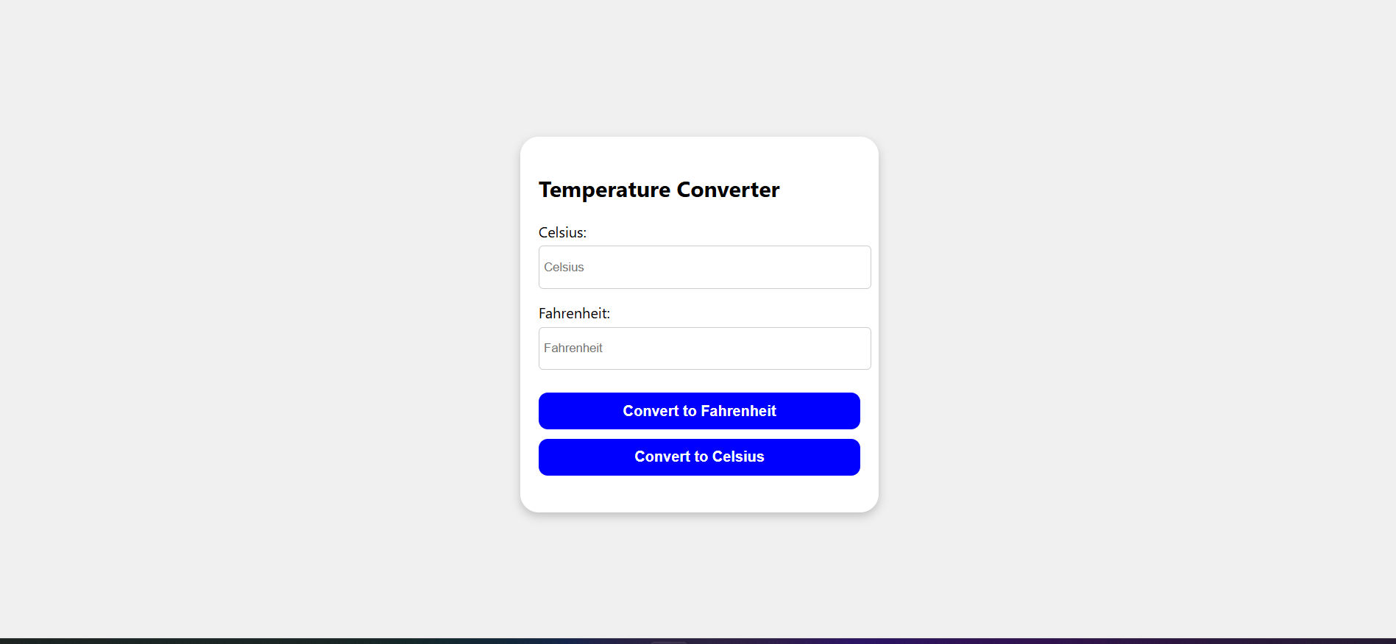
Excepted output
